***Muhammad Kaleem***

***56614***

***Lab no 6***

***Question no 1:***

***Code:***

stack = []

def push(item):

# Adding the item

stack.append(item)

def pop():

# Deleting the item if it is present

if stack:

return stack.pop()

return None

## Empty stack

print("Empty Stack :",stack)

# Adding the item

push(1)

push(2)

push(3)

print("Stack after pushes:", stack)

#Deleting the last element

popped_element = pop()

print("Popped element:", popped_element)

print("Stack after pop:", stack)

#Now printing the last element of list

print("Popping from an empty stack:", pop())

***Output:***

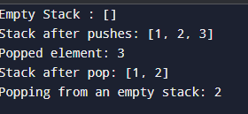

***Question no 2:***

***Code:***

Queue = []

def push(item):

# Adding the item

Queue .append(item)

def pop():

# Deleting the item if it is present in the first index

if Queue :

return Queue .pop(0)

return None

## Empty Queue

print("Empty Queue :",Queue )

# Adding the item

push(1)

push(2)

push(3)

print("Queue after pushes:",Queue )

#Deleting the first element

popped_element = pop()

print("Popped element:", popped_element)

print(" Queue after pop:", Queue )

***Output:***

